**What are three conclusions we can make about Kickstarter campaigns given the provided data?**

1. The most campaigns across all countries were in the following parent categories: theater (1393), music (700) and film & video (600). This comparison was found by looking at the parent categories and the outcomes (state) of the campaigns for all countries.

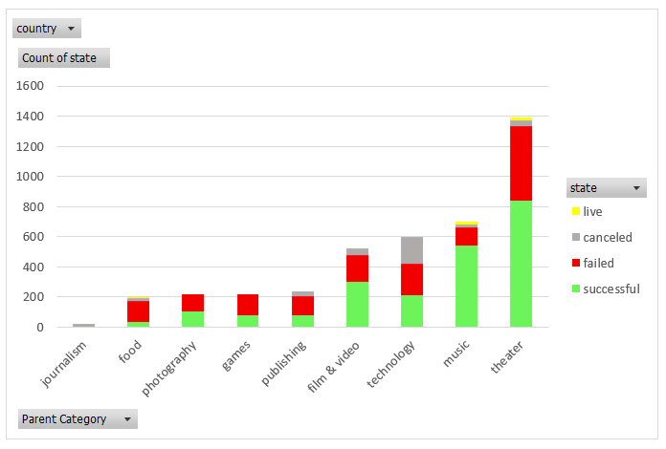

1. At the time the data was collected data, all 260 rock music Kickstarter campaigns were successful. This comparison was found by looking at the sub-categories and the outcomes (state) of the campaigns for all countries.

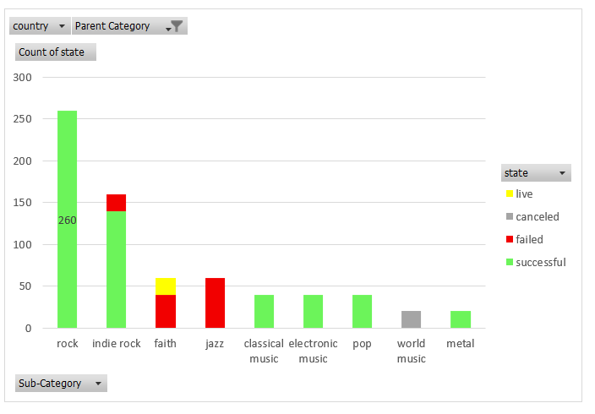

1. For Theater campaigns in the US, the break down between plays, spaces, and musicals was 74%, 16%, and 10%, respectively. This comparison was done by looking at the sub-categories and outcomes (state) of the campaigns in the US.

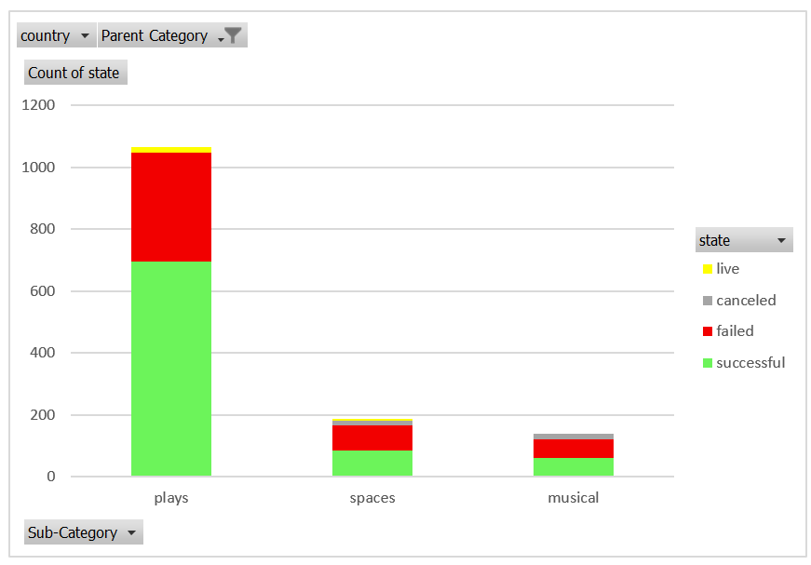

**What are some of the limitations of this dataset?**

Although this data set represents 21 countries, about 74% of the campaigns are from the US, so we have more information on the outcomes of campaigns in the US versus the other countries included in this data set.

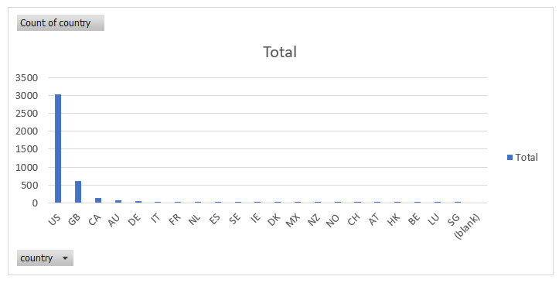

We do not have some values for the criteria of how a campaign becomes a “staff pick” or “spotlight”. Of the total 4,114 campaigns, all 2,185 of the campaigns that were spotlighted were also successful and 1,530 of the campaigns that were not spotlighted failed. It would be worth investigating the reasoning and variables that were used to determine what campaigns would be spotlighted.

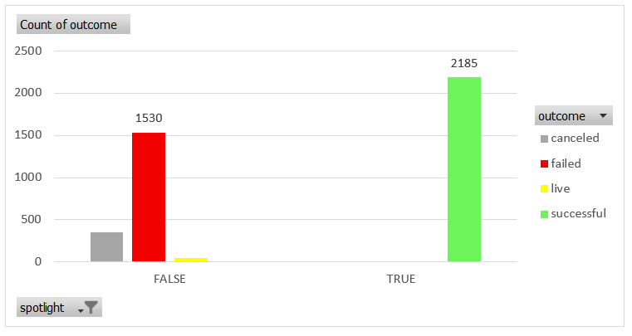

There could also be some campaigns that did not fit into the parent or sub-categories of campaigns, so we may not have a complete picture of all kinds of campaigns. This would also alter what campaign categories that are predicted to more likely succeed.

          Since Kickstarter has started, there have been over 300,000 campaigns launched and our dataset is working with 4,114 of those campaigns or about 1.4% of all campaigns. Our proportion of campaigns is limited, and there is additional information that could be analyzed to get a better idea of trends for campaigns.

**What are some other possible tables/graphs that we could create?**

When I was considering the limitations of the data, I made some tables and charts to see the count of countries represented, staff pick vs state of campaigns, and spotlight vs state of campaigns. Creating the count of countries gave me an idea of where in the world the data was coming from.

The other two tables looking at the relationship between the statuses of staff pick or spotlight and outcome helped me to see if there were any relationships worth looking into. It would be helpful to make a scatterplot of the data after assigning values to the outcomes and staff pick/spotlight status. For the outcomes, 3 = successful, 2 = live, 1 = canceled, 0 = failed and for the staff pick or spotlight status, 1 = True and 0 = False.

Also, discovering the trends over the years of different parent and sub categories of campaigns would be good to see versus just seeing the trends month to month for all years.